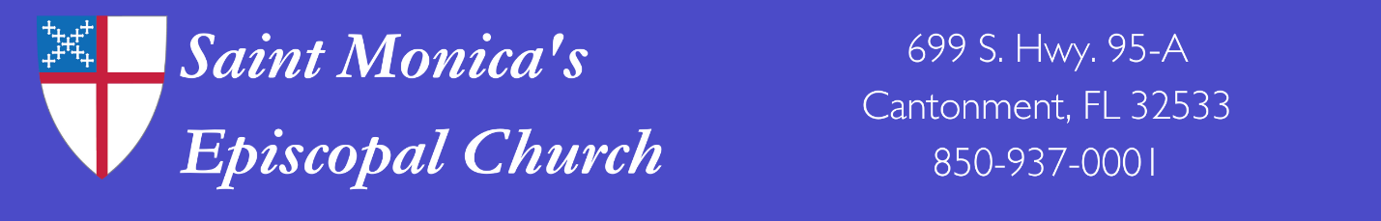
Market Day 2024
Name________________________________________________________________________________
Address______________________________________________________________________________
City___________________________________________State________________Zip________________
Phone__________________________________Email_________________________________________
Please describe your handmade crafts or other items: _________________________________________
_____________________________________________________________________________________
_____________________________________________________________________________________
All spaces are approximately 10ft x 10ft and cost $20.
No electricity is provided.
Number of spaces_______________________ Cost____________________________
Please return your application along with your payment payable to St. Monica’s ECW, (Attn: Market Committee), c/o Beth Woods, 7300 W NINE MILE RD, Pensacola, FL 32526. Our contact information is: Beth Woods 850-450-6637 or email bethw394@gmail.com.
St. Monica’s Episcopal Church will not be responsible for any personal injury or property damage to undersigned vendor or others involved in the vendor’s participation. By participating in any activities on or related to property owned or operated by St. Monica’s Episcopal Church, you assume all risk associated with any injury or damage that may occur. In the event there is a claim of any type made or filed, you agree to hold harmless and indemnify St. Monica’s Episcopal Church from a claim of any type for damage and attendant costs or attorney’s fees. Consideration for assuming such obligations will be permission for your participation in the activity. I have read and understood the terms and agree to same by signing this form.
Signature____________________________________________________________________________
Print Name:_______________________________________________Date_______________________
Please return your application along with your payment payable to St. Monica’s ECW, (Attn: Market Committee), c/o Beth Woods, 7300 W NINE MILE RD, Pensacola, FL 32526

Craft Committee:
Date received: Confirmation:
Amount received: Received by: Cash: Check: Space #:

